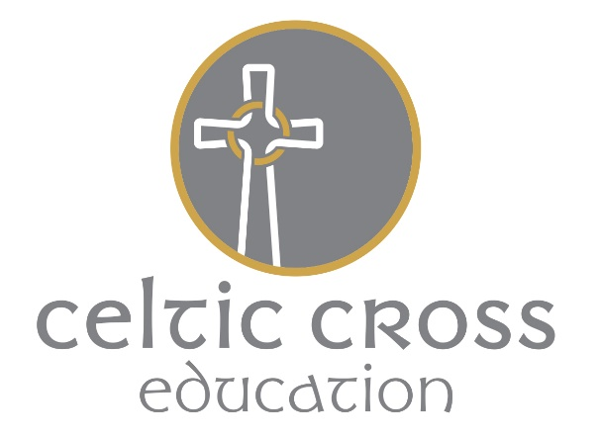

More Able Policy

Introduction

This policy is a statement of the entitlement of children with high ability at this school. It has been developed from reading and research, through staff consultation and by CPD.

The policy now reflects the expertise of staff within the school. It also reflects the commitment of the school to support the able child. The Governors will be aware of these needs and that there should be provision within the budget for resources.

Aims

- To support the abilities, personal qualities and talents of all children.
- To ensure that all children receive an education appropriate to their abilities.
- To provide teaching which makes learning challenging and enjoyable. To provide higher order thinking and questioning skills.
- To employ a wide variety of methods in recognition of potential.
- To recognise under-achievement and to seek to remove it.
- To stimulate children through extra curricular activities and through curriculum enrichment.
- To have the expectation that the curriculum for all will be extended by realising the needs of the most able.
- To sign post children to other agencies if the school does not the relevant staff to support their abilities (eg; specialised sports).

Definition

A more able pupil is one who is in the top 5-10% of the pupil population (DfES definition) and who ‘has the capacity for or demonstrates high levels of performance in an academic area’.

A more able pupil is also one who is in the top 5-10% of those with a domain specific ability in a non-academic area:
- Physical talent
- Visual/performing abilities / creativity
- Mechanical ingenuity
- Outstanding leadership and social awareness

Identification

Before identifying any more able pupil in a particular area, we aim to ensure that all children have had the opportunity to learn and succeed in this area. This makes the identification process fair.

A more able pupil should be identified using a variety of methods. The specific procedure will vary according to subject area but will include elements of the following:
- Teacher observation and assessment
- Summative assessment results
- Parental consultation
- Specific teacher identification
- The use of checklists against criteria where appropriate

It is worth remembering that more able pupils can be:

- Good all rounders
- High achievers in one area
- Of high ability but with low motivation
- Of good verbal ability but poor writing skills
- Very able but with a short attention span
- Very able with poor social skills
- Keen to disguise their abilities

Identification will be a combination of all of these as no one single method can be entirely accurate.
The school will seek to provide an enriched curriculum for all children. Through this it will be possible to identify the most able. The school will then seek to further provide.

Provide – Identify

Identify - Provide

The School is aware of and sympathetic to the potential individual needs of all of our stakeholders. These unique needs may be due to a wide range of circumstances of a long or short duration. We will endeavour to accommodate these to ensure an inclusive approach by promoting positive images and experiences of differing race, gender, LGBT and abilities.

This policy was approved by the Local Governing Body - March 2017.
This policy was reviewed in December 2019 – no change.

