

St Piran’s Post

July 2017 Edition

**ISSUE 10**

**‘Nurturing God’s gifts with compassion and drive, so that all our children succeed, learn and thrive’**

Dear Parents,

Thank you for all of your continued support for your children and all of our schools. The summer term has been an extremely busy term with our assessments, tests, sports days and three MAT wide camps. More on all of these things later in this newsletter.

The last few weeks are always a reflective time as we prepare to say farewell to our Year 6 pupils who will be leaving for secondary school and several of our long serving members of staff.

I hope that you take the opportunity to come into your school during the last few weeks where invitations are extended.

As you know I will be retiring at the end of this term and I would like to thank you for your support during my two years in charge of St Piran’s Cross MAT. All of my efforts and decisions during this time have always focused on what will provide the very best experiences for the children in each of our five schools. We have worked hard to improve the educational provision, opportunities and standards during this time. The schools are working brilliantly together and gain so much from supporting and challenging each other. This will continue under the leadership of the new MAT. I look forward to working with Mrs Lisa Michell during these last few weeks. As you know, she has been appointed as the Hub Leader for the St Piran’s Hub. She will ensure continuity and stability during a period of change.

**MAT Merger**

Our plans to merge with the Saints’ Way CE MAT are on course to happen. We will work as one MAT from the 1st September 2017 and as you may know parents and children have been asked to suggest names for the new MAT. Our central office is moving. From Monday 17th July 2017 our Roche office will close and we will be based at the Saints’ Way offices in Bodmin.

1-3 Omaha Road  
Bodmin  
Cornwall  
PL31 1ER



**Introducing our new MAT Senior Leadership Team**

**Mr Stuart Renshaw – CEO**

I started my career in teaching at a very large school in Wembley, North London in the mid 1980s, I quickly moved through the ranks and moved to Leicestershire in  1993 to take up the position as Deputy Head of a very large school in Loughborough. This four term maternity cover gave me great insight into working in a large primary school. I then moved on to a permanent Deputy Head position before becoming a substantive Headteacher of a small school. I was joined for the five years at the school by my two youngest children: in a school of 60 pupils times were interesting! During this time I was an adviser for the Local Authority’s Investors in People strategy and I trained to be a church school inspector.

It was in 2005 that I made my way to Cornwall to become the Headteacher of St Petroc’s School in Bodmin. During my time there the school became part of the Saints’ Way Multi-Academy Trust and I became the Executive Principal: I think more by the fact that none of my colleagues at the time wanted the responsibility! Seriously, I was honoured to take on the role and work across all the schools in the Trust striving to get the best outcomes for our children. I am a member of the Diocese of Truro Board of Education and I sit as a member of the Cornwall Association of Primary Headteachers.

Having just completed my CEOs training with the Church of England Foundation for Leadership I feel equipped to rise to the challenge of uniting our schools in education. The future is very exciting and I think we are in for some great times ahead. I really want to focus on two principle aims: to build strong relationships and to develop a growing confidence in all leaders and learners. I believe this will enable us to support every one of the 2000 children we will have in the merged Trust. I am very much looking forward to engaging with all the schools and meeting the children who lie at the very heart of all we do.

cid:2F4571EE-6A28-4D2D-BD70-7DAAFE842184@thesaintsway.local

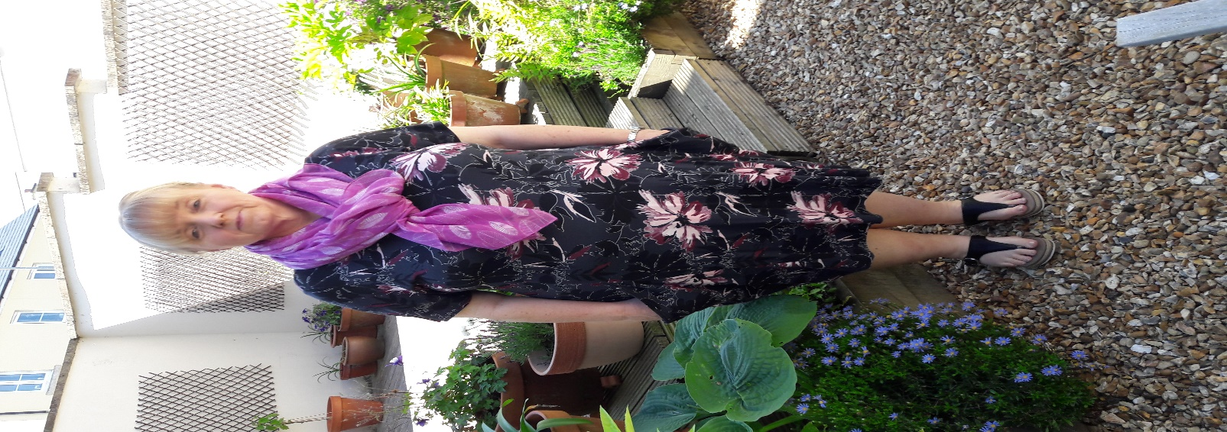**Fiona Corfield – School Improvement Lead**

What is your lasting memory of your time at school? I remember when I took my options at secondary school, I was really keen to learn French. Two weeks in my teacher approached me and said, ‘Do you know. I think you’d be better suited to needlework!’ I was devastated but, I did end my time at secondary school with a really nice gingham apron! This experience helped to cement my educational beliefs and vision, that high quality education is about recognising every child’s potential, empowering them to believe in themselves as successful learners by providing exciting challenges and opportunities, where learning how to learn is as important as what they learn.

My teaching career began in a village school as a Key Stage One teacher and Early Years Co-ordinator in Shropshire. In 1998 I took up the position of Early Years Raise Adviser for Shropshire Local Education Authority with responsibility for consultancy and training for the Foundation Stage, in the maintained and non-maintained sectors, and Key Stage One. In 2002, I became an independent educational consultant, specialising in early years and Primary education, working closely with local authorities nationally and schools in the UK and in Milan. During this time I worked with members of the DfE to deliver national training to Local Authorities across the country, wrote articles for educational periodicals, was invited to give keynote speeches at LA and national conferences and wrote a number of publications, some of which sold internationally.

In 2007, I returned to teaching and became the head teacher of a large primary school in the Midlands. In 2010, we moved to Cornwall and I became the Teaching Head at Lerryn CE Primary School. If you’ve ever been to Lerryn you’ll know what an idyllic setting it is with a tidal creek and beautiful woodland. Following this I then became Executive Head of Lerryn and St Winnow CofE Primaries and in 2013 took up the post of School Improvement Lead for The Saints’ Way Multi Academy Trust.

I am really delighted to have the opportunity to work alongside St Piran’s Cross. Working together we can enable every child to become successful independent learners. Because every child has the right to sparkle and shine!

**MAT Value next half term – Wisdom**

This half term we will be focusing on the wisdom value within our Collective Worship times.

**MAT Choir sings for Bishop Tim**

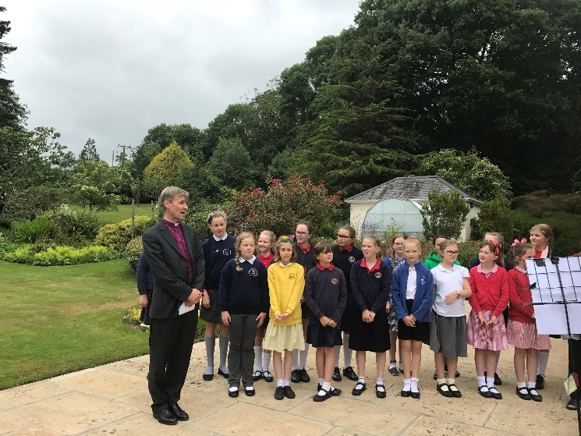A MAT choir went to sing for Bishop Tim at his annual garden party where he invites school leaders and governors. They sang very well and were a credit to their schools.

**MAT Camps**

We have now completed four very successful MAT camps for Year 3, 4, 5 and 6. Some 240 children have attended one of these camps and I would like to thank the children for their commitment, hard work and wonderful behaviour, they have been a credit to their schools and families. I would also like to say a huge thank you to our staff who put their own lives on hold to take our children to camp.

**Barton Hall**

Year 6 spent a fantastic week at Barton Hall in Torquay. The centre and activities were excellent and there were many highlights for the children.

All of the children enjoyed making new friends from other schools.

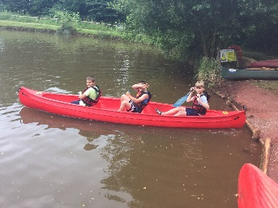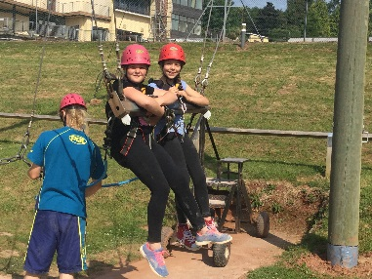**A few photos from Barton Hall Camp**

**Year 6 Leavers’ Red Carpet Ball**

We have invited our Year 6 leavers to a special Leavers’ Ball on **Friday July 21st at Bishop Bronescombe.** There will be transport provided for the children coming from other schools. You will have received a letter confirming the details of this.

Last year this event was hugely enjoyable and

successful. Thank you to the staff and parents who make it so lovely for our pupils in Year 6.

**Summer term key dates:**

**July 12th** – Key stage 2 sports team event at Bishop Bronescombe.

**July 13th** – MAT board of directors meeting at Bishop Bronescombe

**July 14th** – 3 pm – Grampound with Creed Summer fayre – all welcome!

**July 17th** – St Piran’s Cross central office moves to Bodmin, office closed for 17th and 18th July.

**July 19th at 6 pm** – Internet Safety Training event for parents at BB – all welcome.

**July 20th at 6 pm** - – Internet Safety Training event for parents at GR – all welcome.

July 21st at 6.30 pm – Year 6 Red Carpet Leavers’ Ball at BB.

**July 24th, 25th and 26th** – Year 6 leavers’ events, schools will provide the details of these events.

**July 26th – END OF THE SUMMER TERM**

**The Autumn term 2017 starts on Tuesday 5th September 2017.** The staff will be involved in INSET Days on Friday 1st September and Monday 4th September 2017.

Yours sincerely

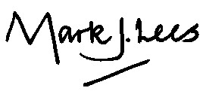

**Mr. M.J Lees**

**Executive Principal**

**Current Trust vacancies**

**Play Coordinator** position at Bishop Bronescombe School. Fixed term contract from 1st September 2017- 31st August 2018.

7.5 hours per week.

Closes Thursday 13th July

For more information visit: [www.stpiranscross.co.uk](http://www.stpiranscross.co.uk)

**Wrap around Care Provision at Grampound Road Primary School.**

We are looking to appoint an after school club supervisor for at least two days a week. This is on a casual contract and parents can book in from 3.15-6.00 pm each day.

As the supervisor you will prepare a healthy snack for them, run a themed evening and activities and supervise the children whilst engaging them in fun activities.

This is a popular provision provided by the school and we are looking for a supervisor for at least two days a week –Thursday and Friday.

If you would like to express an interest in this vacancy please contact [enquiries@stpiranscross.co.uk](mailto:enquiries@stpiranscross.co.uk)